答题卡
题号 | 答案 | 题号 | 答案 | 题号 | 答案
1 |  | 18 |  | 35
2 |  | 19 |  | 36
3 |  | 20 |  | 37
4 |  | 21 |  | 38
5 |  | 22 |  | 39
6 |  | 23 |  | 40
7 |  | 24 |  | 41
8 |  | 25 |  | 42
9 |  | 26 |  | 43
10 |  | 27 |  | 44
11 |  | 28 |  | 45
12 |  | 29 |  | 46
13 |  | 30 |  | 47
14 |  | 31 |  | 48
15 |  | 32 |  | 49
16 |  | 33 | 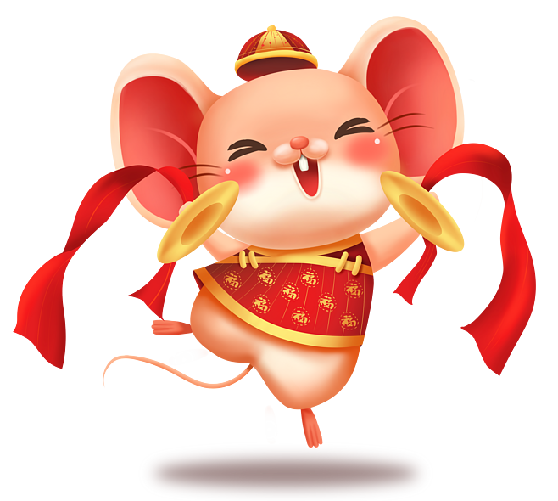 | 50
17 |  | 34

